**AGRAGAMI (HR Club)**

**Hosts**

**"GET SET GO"**

**Team Building Event**

On December 4, 2023, the dynamic team of AGRAGAMI (HR Club) organized an engaging team-building event titled "GET SET GO" near Six Pillars. The event commenced at 4:00 PM with an informative briefing from the HR Club coordinators, who outlined the rules and guidelines for the thrilling scavenger hunt.

A total of seven teams, each comprising four members, embarked on the exciting quest, armed with identical sets of questions. The challenge was to meticulously gather the answers, perform the tasks and submit the completed sheets to the HR Club coordinators within the allotted time of 30 minutes.

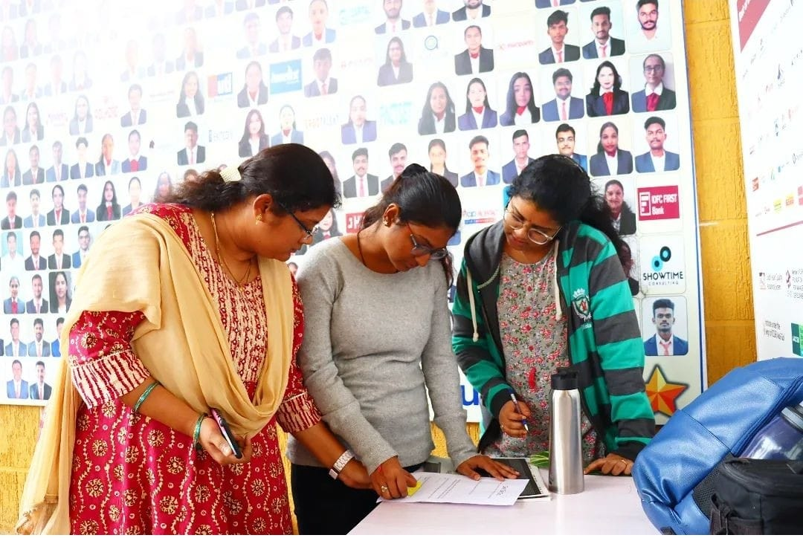

The winners of this event are :- Shiba, Sounak, Abhirook, Reggie.

As the teams navigated through the scavenger hunt, their collaborative spirit soared, fostering camaraderie and teamwork. The event culminated in a group photo capturing the vibrant energy and enthusiasm of all participants, including the HR Club coordinators. With the last task completed at 4:50 PM, the event concluded on a high note.

"GET SET GO" proved to be a resounding success, effectively promoting team bonding, problem-solving skills, and time management while providing a platform for members to engage in an enjoyable and stimulating activity. The event reinforced AGRAGAMI's commitment to fostering a vibrant and engaging work environment.