IPE SPEAKOUT CLUB SESSION
“CHERISHED PHOTOS: BREAK THE ICE”

6th of September 2023
The event had a unique theme: "BRING A CHERISHED PICTURE." Participants were asked to choose a special photo and share why it was meaningful to them. This exercise helped them practice speaking in front of a friendly and supportive audience.

Speakers: -
Ambica (PGDM-A) Junior
Tejaswini (BFS-A) Senior
Spandana (BFS-A) Senior
Kirthana (PGDM) Junior
Soundarya (Marketing) Junior
Aditi (BFS-A) Junior
Pragya (PGDM-B) Senior
Divya (PGDM-A) Junior
Fatima (IB) Junior
The were a total of 9 participants from the first year and second year.

Minutes of the meeting – Hashmita (coordinator)
4:00 PM - Soundarya and Neha (Coordinators)
Opening Introduction
Instagram live event Coverage – Arun Kumar Reddy

Here are some photos of the event-

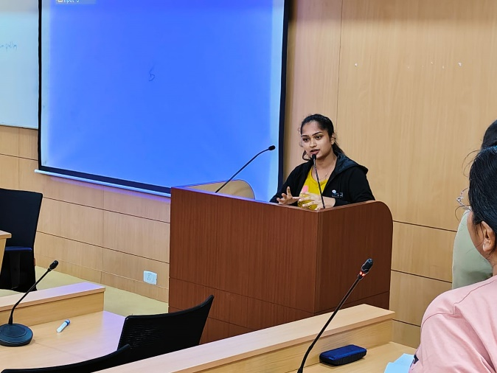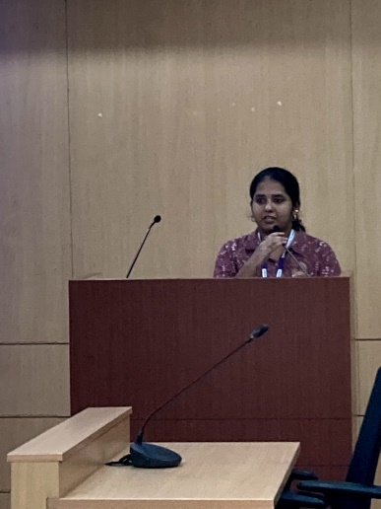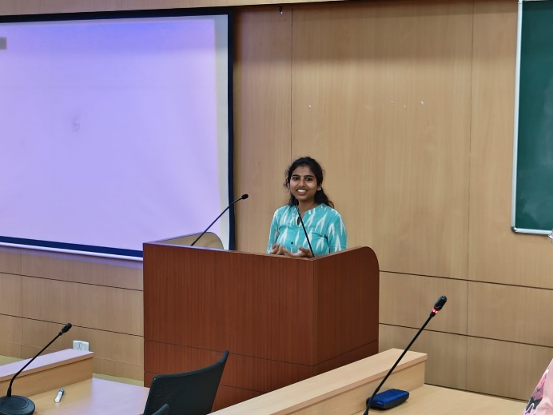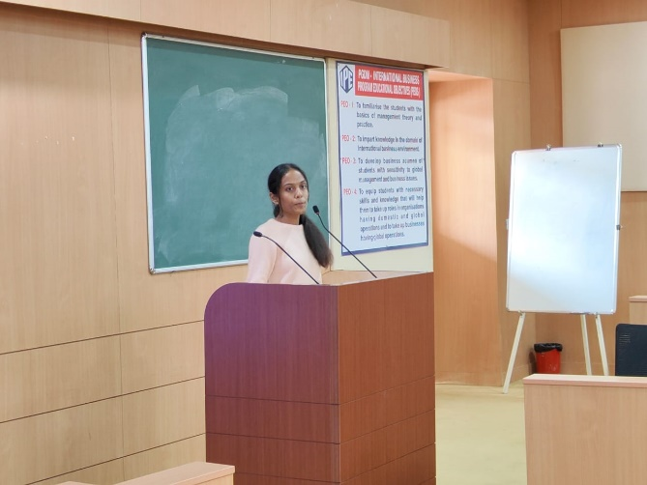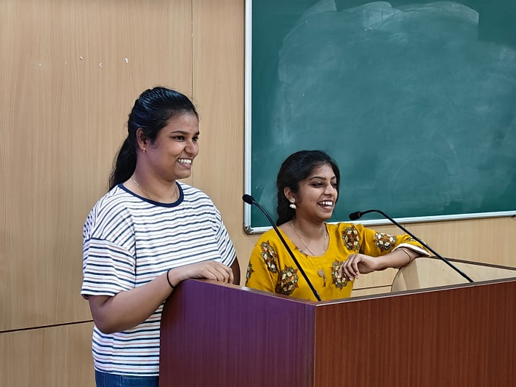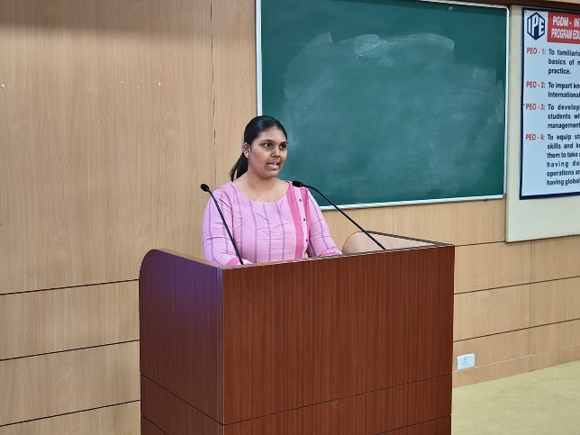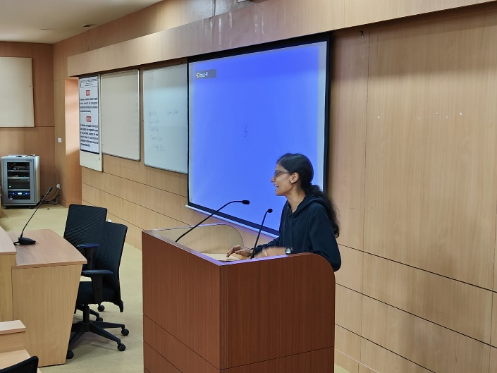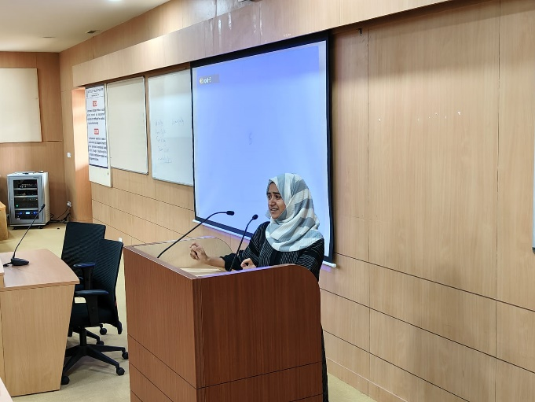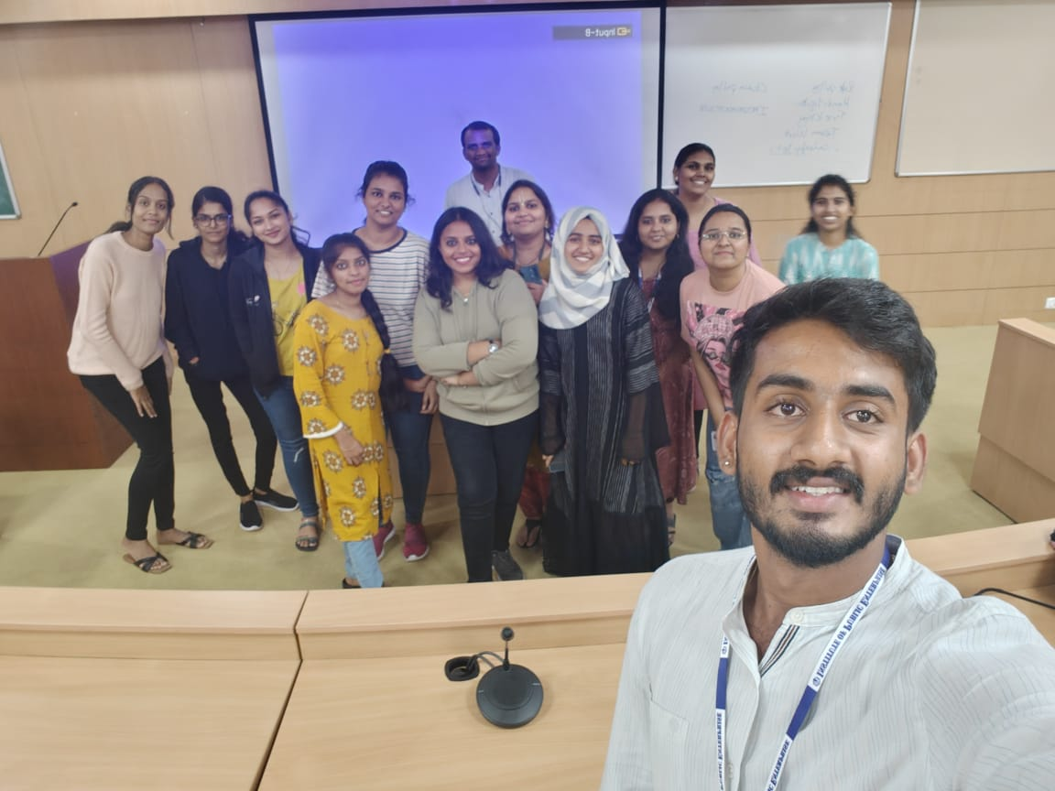

Speakers | Topic | Time Stamp
Ambica | Visit to the orphanage | 4:05-4:10
Tejaswini | Fond Memories from her adventure | 4:10- 4:15
Spandana | Thoughts on Family | 4:15-4:20
Kirthana | Lessons from Friendship | 4:20-4:25
Soundarya  Aditi | Regarding their deep and enduring friendship. | 4:25-4:30
Pragya | Childhood- A time of happiness and positivity. | 4:30-4:35
Divya | Bhadrachalam Trip | 4:35-4:40
Fatima | Modernism and society’s view on hijab. | 4:40-4:45

In addition to this, the event essentially focused on improving public speaking skills. The event encouraged attendees to interact with people from different backgrounds and make new connections. Students from both the first and second years attended and talked about a wide range of topics, like their visits to orphanages, childhood memories, and their relationships with family and friends; also discussed important subjects such as personal growth over time and dispelling stereotypes about the hijab. Overall, the event provided a welcoming platform for those interested in public speaking and a comfortable space for those who might be hesitant.
4:45- Vote of Thanks - Hashmita, Soundarya, Neha (coordinators)

