The CONCURSO in Statistics:

Statistics Quiz contest.

Date: 27 – 09 – 2023
Venue: Seminar Hall – 1
Time: 3:40 – 4:45 PM
Total No. of Registrations of Students: 15 teams
Total candidates who turned up for the event: 30 members

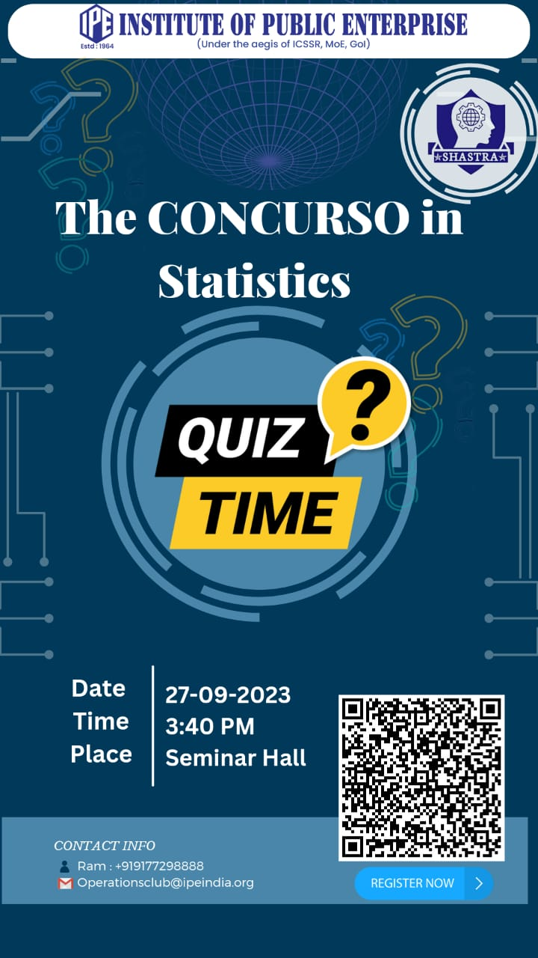
The CONCURSO in Statistics: Statics Quiz competition
3:40 – 3:55PM | Gathering of Students and Faculty
3:55 – 4:10 PM | Welcome students and Faculty, Introduction of the event and Judges.  Speaker – Prof. Rajkumar Pillai sir
4:10 – 4:15 PM | Explanation of Game rules
4:15 – 4:25 PM | Round -1
4:25 – 4:30 PM | Evaluation of round 1 and announcing the participants of round 2
4:30 – 4:40 PM | Round - 2
4:40 – 4:45 PM | Evaluation, Winner’s, and Runner’s announcement by faculty.

Judges:

Dr Raj Kumar Pillai – Associate Professor – Analytics and Coordinator – Student council.
Dr Abhay Srivastava – Associate Professor – Operations.

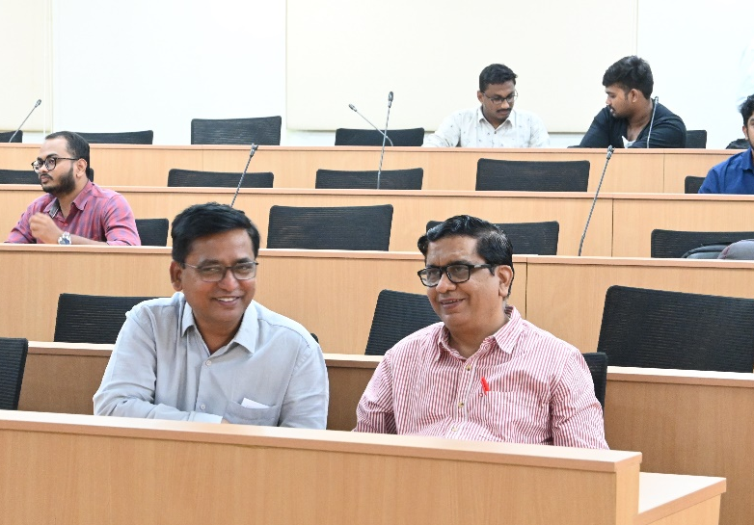

Volunteers of the event:
Juniors: Kondle Venkateshwarlu – 2303039

SHASTRA – The operations and Analytics club at IPE has conducted their second event The CONCURSO in Statistics – Statistics quiz contest.

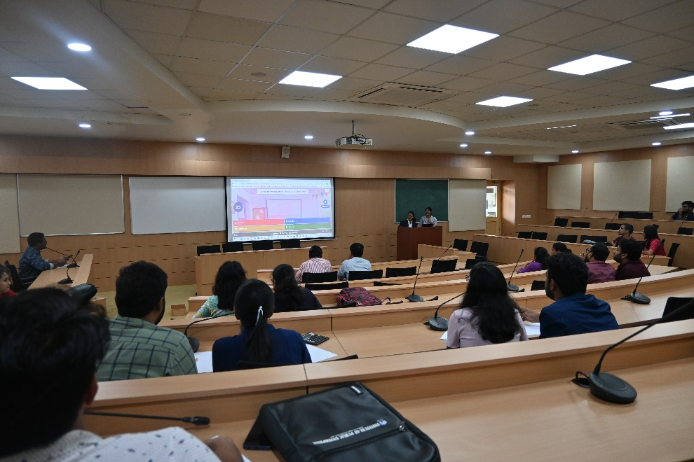
The event was planned from 3:40 PM. By 3:55 PM all the faculty & students gathered at the seminar hall -1. The Game started at 4:00 PM by welcoming the esteemed faculty members and our judges for the day Dr. Rajkumar Pillai sir and Dr. Abhay Srivastava sir.
The students were addressed by Dr. Rajkumar Pillai regarding the importance and applications of Statistics. Use of Statistics for managers in business applications. The importance of understanding and comprehending statistics that is being taught to first-year students in this trimester is discussed by mentioning the practical applications and uses.
This is followed by explanation of Rules of the game.
Game is of 2 rounds. Participants shall be processed through 2 rounds. Each team should have one mobile and one calculator with them. Teams will earn points for each correct answer. Incorrect answers will not result in a deduction of points.

Round I:
All the teams that signed up will be playing this round.
Participants should play the first round online with the provided link/code of KAHOOT Online quiz platform.
Teams will have a specified time limit (e.g., 30 seconds) to answer each question.
Jury will finalize the Top scorers, who are further promoted to the next round.

Round II:
All the top scored teams will be participants of this round.
The questions will be displayed on the screen. Each question has time limit of 2 minutes. Once the time’s up teams should be raising their hands to answer the question.
One chance for each team will be given who has answers for the question.
The winner and a runner up will be chosen as per the final scores by the jury.
As round 1 is conducted online the participants for the second round were decided easily.
Top 5 participants are selected to the next round.
Teams that were promoted to round 2 are named as α, β, ϒ, µ, ∆. 5 questions were displayed on the screen one by one with 2 minutes of timer to each question.
We had a top scorer i.e., Winner by the end of the round. But there is a tie between 2 runner ups. As a tie breaker we had to display another question, the team answers first among the 2 wins the game.
We have a winner team and one runner team by the end.
The results are announced by Prof. Abhay Srivastava sir.

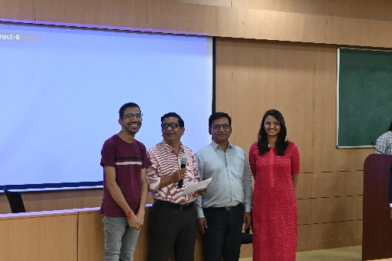
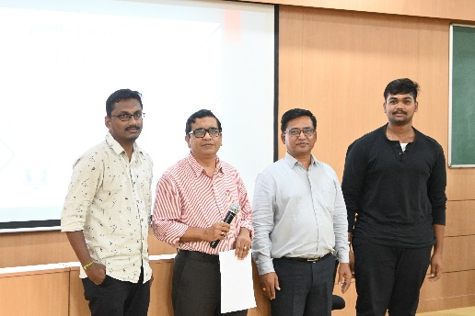

Winner team: Runner Up Team:
Deevi Naveen -2303106 Akshat Agrawal - 2203005
Y. Ravi Teja – 2301061 Minka Bhargava - 2203059

Team Shastra:

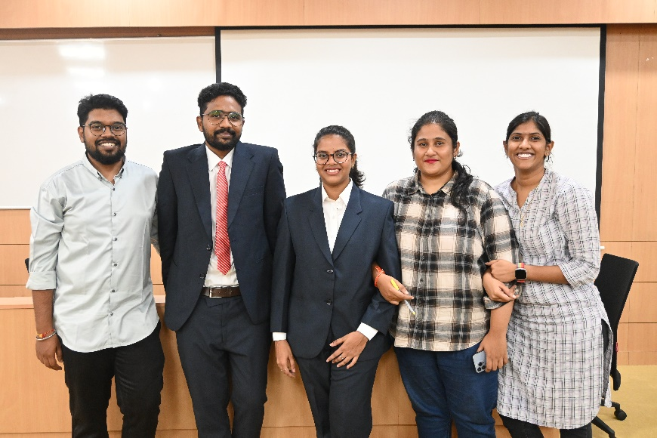

E-Certificates for Winners and Runners, also to all the participants are provided.

