Dr. Kiranmai Dutt Pendyala linkedin.com/in/kiranmai-pendyala-94335427
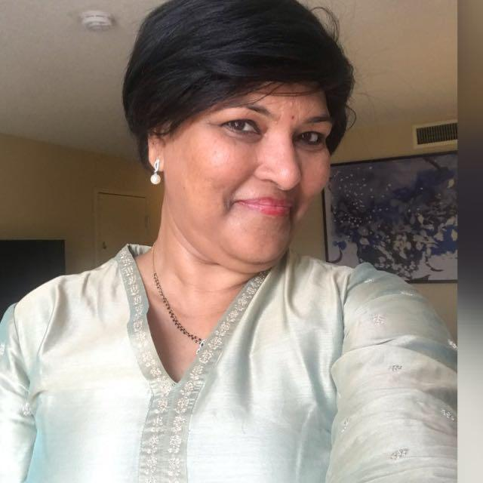
Corporate Vice President, Human Resources
UPS Global Technology Center, India &
Board Member, UnitedWayHyderabad (‘for Impact’ Organization)

Dr. Kiranmai Dutt Pendyala is currently Corporate Vice President, Human Resources, UPS, a Fortune 100 world leader in supply chain and Logistics. She was formerly, Head Human Resources, Western Digital India.

Kiranmai Pendyala is also the Governing Body Member on several Higher Education Institutions / Deemed Universities as well as on United Way, Hyderabad, a Not for Profit- “for Impact” organization.

She was earlier the Head of Human Resources and Site Administration, Intercontinental Exchange (ICE) India, the parent company of New York Stock Exchange (NYSE), starting its Data Services operations in India in 2019. Dr. Dutt was also the Corporate Vice President, Human Resources, at AMD, led the HR Infrastructure, Systems, Services, Tools, Technology, Employee Relations, Analytics, Processes and Policies globally. In her former role Dr. Kiranmai was the Regional CHRO, CVP, HRBP for the vast region outside Americas- Greater Asia, and EMEA Regions, and straddled the region responsibility for strategic plans on talent acquisition, talent management, and talent development and partnered with the Human Resources Leaders in her First Team to represent the employee voice of the Region. Dr. Kiranmai has good knowledge of Employment Laws across the countries in EMEA Region, APJ Region, and Greater China Region, given her HR Executive Role covering the regions, outside the Americas.

She was the Head of a Center of Excellence at the ISB- Center for Leadership, Innovation, and Change (CLIC) and partnered with industry champions like OP Bhatt of SBI, for the SBI transformation project, Ms. Kiran Mazumdar Shah of Biocon on Innovation Models, etc.

Dr. Kiranmai was the former chairperson of AMCHAM, ISTD, and an Executive member of IESA, NHRD, HYSEA, and CII Committees.

Dr. Kiranmai brings together a unique blend of keen academic focus and organizational experience. She has successfully straddled diverse roles in teaching, training, human resource development, consulting, quality, and technical writing. She is an accomplished author with multiple of her books prescribed as curriculum by various universities across the country.

Three Decades of Professional Experience with a blend of Academics, Research, Angel Investments, Not for Profit, & Corporate Executive Leadership roles.

Most notable roles:

- First Corporate Vice President, HR for AMD, (outside the Americas in its 50-year history), a Fortune 500 Semiconductor Company, led various domain portfolios in the global role encompassing 58 countries and all the five Continents, including M & A, HRBP, Lo& D, Culture, ER, Tools & Technology...

On the Board of several Higher Education Universities, author of multiple books, recipient of several awards, and spends the weekends on two passionate portfolios-

- Mentoring and strategizing for United Way of Hyderabad, a ‘For impact’ Charity Organization

- Reviewing investments as an investor into tech startups for a SEBI registered Indovation Fund and a private equity fund investing in mature Tech enterprises

Dr. Kiranmai given her educational background in Management, law, and Psychology, and overall experience of 30+ years enjoys her leisure time with her only daughter who is a lawyer with Masters from George Washington law, D.C., USA, and her life partner, an entrepreneur with agri- based and physical infrastructure interests.

***

