IPE - Center for Corporate Social Responsibility



The Centre for Corporate Social Responsibility (CCSR) was set up during 2011 to promote training, research, consultancy assignments and document case studies in thrust areas of CSR. The Centre works on the existing body of knowledge, systems, structures, models and mechanisms associated with different CSR initiatives; it also provides a platform for discussing CSR guidelines and the latest developments in the field.

The Institute of Public Enterprise (IPE) has been part of the Department of Public Enterprises (DPE), Government of India initiative on introducing Corporate Social Responsibility (CSR) as an element of the performance matrix in Central Public Sector Enterprises (CPSEs). IPE was invited to attend the meetings of the Working Group on CSR in 2007-08 and 2009 -10, and was nominated by DPE as a Member of the Executive Committee on CSR in 2011 to develop, design and implement courses for CPSEs. Recognizing the importance of the subject and also the realization that there is a dearth of experts in this emerging field, it was decided that IPE could play a major role in research, development and advocacy of CSR. This idea led to the establishment of the Center for Corporate Social Responsibility in 2011 at IPE.

Objectives of Centre for Corporate Social Responsibility
- To conduct interdisciplinary and collaborative research and document case studies in thrust areas of CSR dealing with contemporary issues and challenges.
- To integrate the existing body of knowledge, systems, structures, models and mechanisms associated with different CSR initiatives by interfacing with industry and academia
- To disseminate information about the latest happenings in the CSR field to the people engaged in policy making, policy analysis, policy research, practitioners and other stakeholders

Purpose
CCSR provides quality Training, Consultancy and Research in the following areas of CSR.

- Conduct training programmes in the areas of CSR with respect to latest guidelines, existing laws and international initiatives.
- Conducting baseline surveys and need assessment.
- CSR program planning and implementation.
- CSR monitoring and impact assessment.

Core areas of IPE’s CCSR
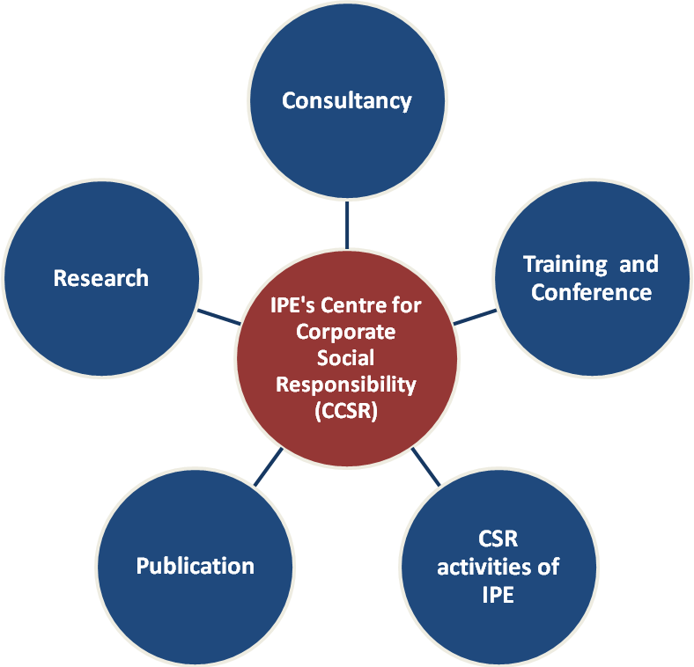

Advisory Committee members:
- Mr. SK Acharya, CMD, NLCIL

Mr. R Shankar, Head Quality , EHS, Sustainability & Business Excellence, Tata Projects.
- Dr. N K Raju, ED (P&A), BDL.
- Prof. R K Mishra, Senior Professor and Director, IPE

Members of the Center:
- Dr. Shulagna Sarkar (Center – Coordinator, IPE)
- Ms. Kiranmai Janaswamy (Member)
- Dr. Deepti Chandra (Member)
- Mr. CS T Anil Kumar (Member)

Activities of the Center for Corporate Social Responsibility

The institute is empanelled by TISS as a center for training, research and consultancy in the area of CSR
Training and Conferences: As many as 28 training programmes have been organized by the center for various CPSEs, private sector companies and NGOs. Our participants list consists of organizations such as NMDC Ltd, BHEL, HAL, PGCIL, GAIL, RINL, NALCO, ADP, Amararaja Batteries, NTPC Ltd, HCL, MOIL, MDL, IOCL, ONGC, NLC Ltd., MRPL, ONGC Videsh and many more. The center has been organizing CSR conference every year to disseminate research outcomes in the area of CSR.

IPE is also a partner to IICA for its 9 month certificate programme in CSR.

Training Programs, MDP’s conducted by the Center
- The CCSR conducted a two day training programme on CSR, 14th-15th July, 2016. Delegates from various organizations such as Ashland India Pvt. Ltd., Ajax Fiori Engg I Pvt, Ltd. PNB, ECIL, RINL, DQ entertainment I Ltd. , CSL, APMDC, KPL, NTPC, participated in the programme. The programme was conducted by Dr. Punam Singh and Dr. Shulagna Sarkar.
- An open Programme on CSR was also conducted on 5th and 6th December, 2016, with participants from NLC Ltd., HAL, Sterling and Wilson, Bajaj Auto Ltd. NLC and Petronet LNG, CMPDI, and NMDC. The programme was conducted by Dr. Shulagna Sarkar and Dr. Punam Singh.
- A three day CSR program was also organized in association with CIRE, Hyderabad dated 15th - 17th Feb, 2017. The programme was coordinated by Dr. Shulagna Sarkar.
- IICA – ICP programme on CSR, ICP is a 9 months programme on CSR. The Institute has signed a MoU with the Indian Institute of Corporate Affairs (IICA) for conducting the IICA Certificate Programme(ICP) in CSR (ICP-CSR) as one of its partner organizations. The ICP-CSR is a 9 month programme for developing trained and certified CSR professionals in the country. IPE has successfully completed its 2nd batch of ICP in CSR in association with IICA. The course has been run by Dr. Shulagna Sarkar and Dr. Punam Singh
- Two day training programme, Managing CSR for High Impact, 25-26th June, 2015.
- Awareness Programme on CSR, 24th Jan, 2015 for General Manager, NLC Ltd.
- Awareness Programme on CSR, 23rd Jan, 2015 for Chief Manager, NLC Ltd.
- Two day open programme in CSR, 4-5th August, 2014.
- Two, One day In-house training programme on CSR and Sustainable Development at MECON, Ranchi on 7TH and 8TH Feb, 2014.
- One day In-house training programme on CSR and Sustainable Development at HAL, Bangalore on 16th September, 2013.
- A two day open training programme was organized by the center in the area of CSR, 13-14th June and 5-6th September, 2013.
- CCSR had organized a two day training program on Corporate Social Responsibility for BDL, Bhanur unit, 28th feb -1st March, 2013.
- CCSR has organized three day training program on Corporate Social Responsibility for PGCIL. on 22nd – 24th November, 2012
- CCSR has organized in-house two day workshop on Corporate Social Responsibility for
- Bharat Dynamics ltd. on 19th – 20th April, 2012.
- CCSR has organized two training programs in association with National institute of Rural Development, Hyderabad for Hindustan Copper Ltd. on 1st Feb, 2012 and 21st – 23rd Feb, 2012.
- With sponsorship support from Neyveli Lignite Corporation Limited, CCSR organized a workshop on CSR on 13th September 2011 at New Delhi.
- CCSR organized a Management Development Program on CSR on 28th - 29th Oct, 8th - 9th Nov, 24th -25th Nov and 8th - 9th Dec 2011 at IPE.

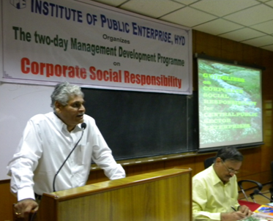 | 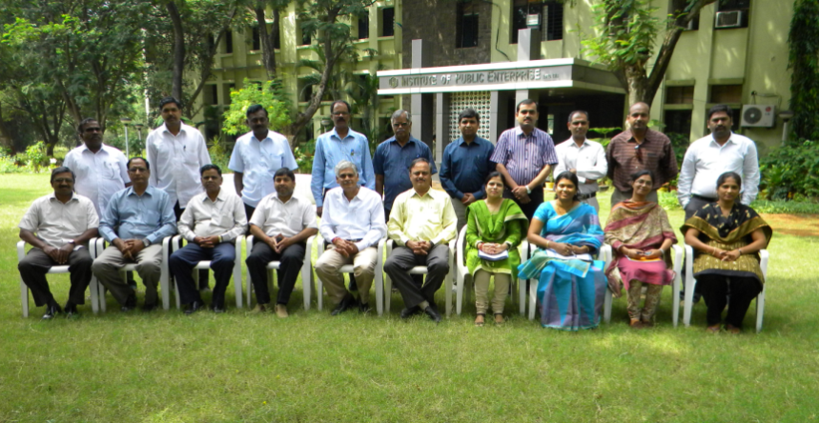
Prof. Mishra addressing the participants at two day MDP on Corporate Social Responsibility’ 28th – 29th October, 2011 | Participants of the two day MDP on Corporate Social Responsibility’ 28th – 29th October, 2011

Consultancy
- CCSR completed the impact evaluation of CSR and Sustainability projects of NLC.
- The Center has completed a CSR validation and Impact study for TPCIL and NCCPPL.
- CCSR has conducted the Impact Assessment Survey of the CSR initiatives of BDL 2013-14.
- Designed the CSR five year plan document for Bharat Dynamics Limited.
- Designed the CSR policy document for Bharat Dynamics Limited, 2012
- The centre extended its local support to TISS, Mumbai in conducting the baseline survey for BDL, Hyderabad 2012 – 13.
- Impact assessment study for MIDHANI Ltd. 2012 – 13
- Baseline study for identification of projects for MIDHANI Ltd. 2013 -14.
- The centre conducted the baseline for specific projects for heart surgeries for Innova Heart Foundation and for school operating at Kachanbagh.
- Baseline survey for Neyveli Lignite Corporation Limited
The centre conducted a Baseline survey for Neyveli Lignite Corporation Limited for undertaking CSR projects as per DPE guidelines. The survey was conducted for 120 villages in five phases. Various projects were identified in the area of Healthcare, Environment, Infrastructure development, Income generation, Education and Women Empowerment.
 | 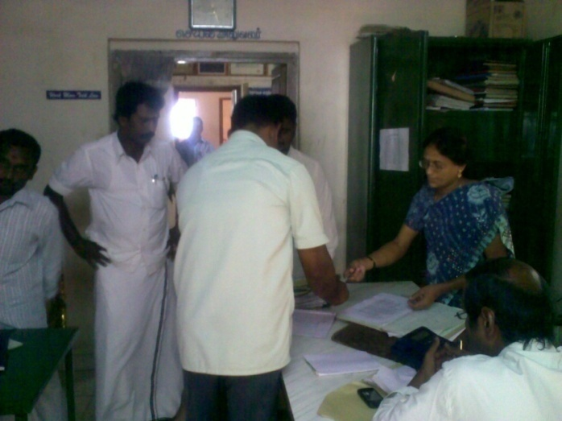
Visit to Walaja lake for identifying the need for desilting while conducting baseline survey for NLC. | Visit to PHC at Kammapuram village while conducting baseline survey for NLC.

- Impact assessment study for ONGC Ltd.
The centre conducted an impact assessment study for ongoing projects of ONGC. The projects were from different areas of education, health and infrastructure development. The projects were Computer Course by Gandhi Institute of Computer Education and Information Technology, Mobile Medicare Unit and construction of Harit Moksha.

Publications:
- Mishra, RK. and Sarkar, S., (2017) ‘Corporate Social Responsibility’ Driving a sustainable future’ Edited book published by Academic Foundation, New Delhi ISBN 978-93-32704-11-4
- Mishra,R.K and Sarkar, S.(2017) Corporate Social Responsibility in India, ‘Corporate Social Responsibility’ Driving a sustainable future’ Mishra, RK. & Sarkar, S. (Ed) Academic Foundation.
- Sarkar, S(2017) Is CSR an approach to address Social risk, ‘Corporate Social Responsibility’ Driving a sustainable future’ Mishra, R.K. & Sarkar, S. (Ed) Academic Foundation.
- Sarkar, S and Pingle, S. (2017) Corporate Social Responsibility: A Cross country view, ‘Corporate Social Responsibility’ Driving a sustainable future’ Mishra, R.K. & Sarkar, S. (Ed) Academic Foundation.
- Chandra, D. (2017), Role Of Corporate Social Responsibility and sustainability in the SME Sector, ‘Corporate Social Responsibility’ Driving a sustainable future’ Mishra, R.K. & Sarkar, S. (Ed) Academic Foundation.
- Sridharaj, A. (2017), Looking Beyond CSR: The Socially Oriented Enterprises (SOEs) Way, ‘Corporate Social Responsibility’ Driving a sustainable future’, Mishra, R.K. & Sarkar, S. (Ed) Academic Foundation.Mishra, Singh, Sarkar (2014), ‘Towards Addressing Social Sector Issues in India: A Corporate Social Responsibility Approach’, in The Indian Social Sector: Trends and Issues (ed.) by Mishra and Akundy, Academic Foundation.
- Mishra, Sarkar, Singh (2014) ‘Revolutionizing Corporate Social Responsibility’, Academic Foundation, New Delhi.
- Mishra, Singh, Sarkar, (2014) Rethinking CSR - Case of oil and Gas sector in India, Corporations and Sustainability: The South Asian Perspective, Greenleaf Publishing Ltd., Sheffield, UK (In Press)

Mishra,R.K., Singh,P., Sarkar, S. (2013) Corporate Social Responsibility in India for a Sustainable Inclusive Growth, Administration and Management Review, Vol. 25, No. 1, Nepal. pp. 39-58.
- Sarkar, S and Singh,P (2013) Corporate Social Responsibility: A Way Towards Women Empowerment , International Journal for Management Research. Vol - 4, No. 1 Abstract Online: www.publishingindia.com
- Singh,P and Sarkar,S. (2013) CSR Guidelines for Indian Companies, Indian Journal for Corporate Governance. Vol - 6, No. 1
- Mishra, Sarkar, Singh (2012), (eds.) ‘Strategic Corporate Social Responsibility’, Delhi: Blooms Publishing India Pvt. Ltd. ISBN 978-93-82563-42-6
- Mishra, Sarkar, Singh, (2012), ‘Linking CSR to business strategy: The Balanced Scorecard approach’ ‘Strategic Corporate Social Responsibility’, Delhi: Blooms Publishing India Pvt. Ltd. ISBN 978-93-82563-42-6
- Mishra, Sarkar, Singh, (2012), Repaying the Society, Upakram Apr- June 2012.
- Mishra, Singh, Sarkar (2011), (eds.) ‘Rethinking Corporate Social Responsibility’, Delhi: Macmillan Publishers India Ltd. ISBN 023032310 -3
- Mishra, Singh, Sarkar (2011), ‘International trends in Corporate Social Responsibility: Oil and Gas Sector Perspective’ in ‘Kaleidoscope’, SCOPE
- Mishra, Sarkar, Singh, (2012), ‘Corporate Social Responsibility: Oil and gas sector in India’, CSR - A social agenda' edited book, Adhyan Publishers, New Delhi
- Sarkar and Singh, (2011), Corporate Social responsibility – The awakening’ in The Hitavada - Future supplement, 21st Feb, 2012
- Mishra, Sarkar, Singh, (2011), ‘CSR – The role of Corporate for a sustainable tomorrow’ ‘Rethinking Corporate Social Responsibility’, Delhi: Macmillan Publishers India Ltd.
- Mishra, Ravi Prakash, (2011), CSR Initiatives: A Case study of ITC Ltd. In Mishra, Singh, Sarkar (Eds.), Rethinking Corporate Social Responsibility, edited book, Delhi: Macmillan Publishers India Ltd.

Conferences/ Congress Organized:

- 4th International Conference on CSR at IPE, 2nd -3rd Feb, 2017
Centre for Corporate Social Responsibility (CCSR) of Institute of Public Enterprise, Hyderabad organized the 4th International Conference on Corporate Social Responsibility’ on 2nd – 3rd February, 2017.The conference was organized under the aegis of NLC Chair on CSR at IPE-Shamirpet campus. The event was sponsored by Indian Council Social Science Research and supported by NMDC Ltd.

Prof. R K Mishra, Conference Chair and Director, IPE welcomed the guests. The inaugural address was delivered by Dr. Madhukar Gupta, Additional Secretary, Department of Public Enterprise, GoI. The key note Address was delivered by Dr. Samar Verma, Sr. Programme Specialist, IDRC Asia Region. The guest of honor of the event was Mr. S Sridhar, Executive Director, NLC Ltd. Prof. A K Rath, (IAS, Retd.), Chairman and Prof, Center for CG&SR, IMI, New Delhi delivered a special address during the conference. Dr. Jibitesh Rath, GM- HRD, NMDC ltd. also delivered a special address during the conference. The convener for the conference was Dr. Shulagna Sarkar.

Dr. N K Raju, Executive Director, BDL delivered the valedictory address of the conference. Dr. Ajay Gupta, In-charge (Publication & Research Surveys), ICSSR was Guest of Honor for the valedictory session of the conference. More than 35 papers were presented during the conference including papers from Bangladesh, Mexico. A book titled: ‘Corporate Social Responsibility – Driving towards a Sustainable Future’ edited by Prof. R.K Mishra and Dr. Shulagna Sarkar was also released during the conference

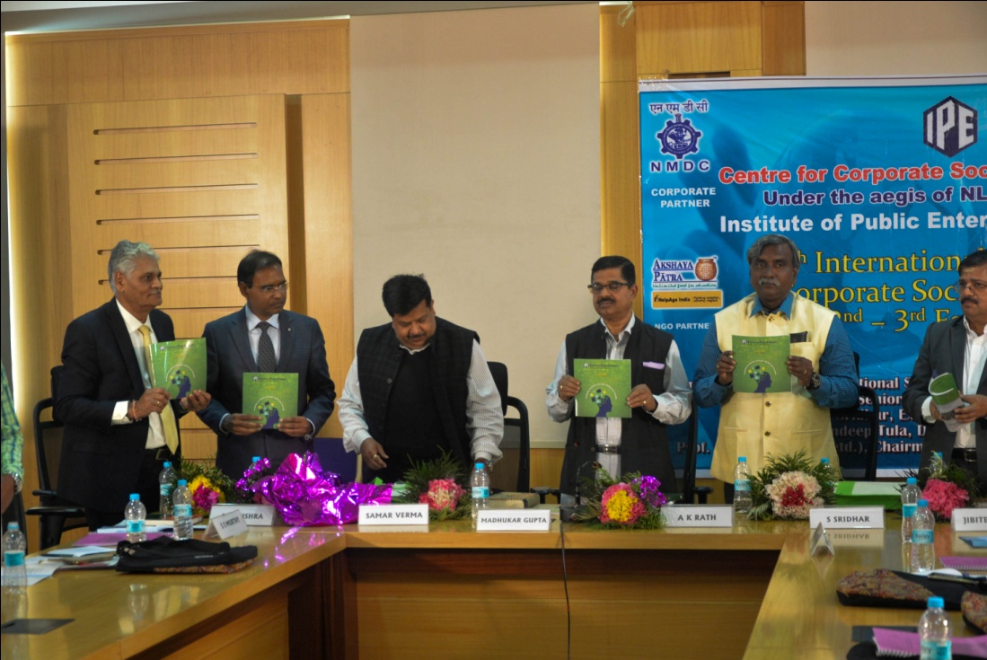
(From Left to right) During Inaugural session: Prof. R K Mishra, Director, IPE, Dr. Samar Verma, Sr. Programme Specialist, IDRC Asia Region, Dr. Madhukar Gupta, Additional Secretary, Department of Public Enterprise, GoI. Prof. A K Rath, (IAS, Retd.), Chairman and Prof, Center for CG&SR, IMI, New Delhi, Mr. S Sridhar, Ex Director, NLC Ltd. and Dr. Jibitesh Rath, GM- HRD, NMDC ltd.
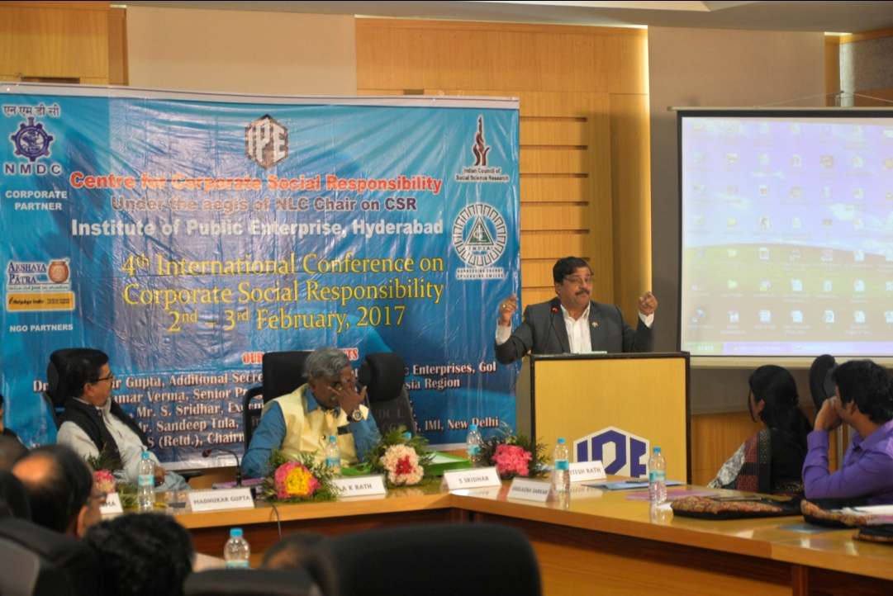
Dr. Jibitesh Rath, GM- HRD, NMDC ltd. delivering special address during the conference.
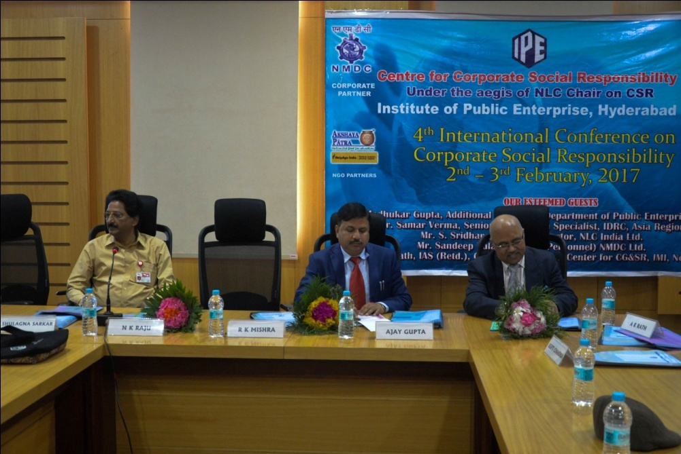
(From left to right) During Valedictory session :Dr. N K Raju, Executive Director, BDL, Dr. Ajay Gupta, In-charge (Publication & Research Surveys), ICSSR and Prof. P K Chaubey, Former Professor, IIPA, New Delhi.
- Two Day Global Congress on CSR 5th – 6th Dec, 2014
The Centre for Corporate Social Responsibility at Institute of Public Enterprise, Hyderabad under the NLC Chair on Corporate Social Responsibility organized a two day Global congress on Corporate Social Responsibility on 5th -6th December, 2014. The lead sponsor of the event was Hindustan Copper Ltd. and the Co Sponsors for the event were NMDC and State Bank of Hyderabad. The congress was organized with the objective to deliberate upon the existing practices and future prospects of CSR in the backdrop of Section 135 of the Companies Act, 2013.To highlight the ‘Best Practices in CSR’ in the context of business sustainability, to discuss the implementation models and structures that can be used in all sectors of industry and to create awareness of the latest thinking on CSR and governance issues as a driver of change, innovation and sustainable profit. Prof R K Mishra, Chair Professor, NLC Chair on CSR was the Congress Chair and the Congress conveners were Dr. Shulagna Sarkar and Ms. Punam Singh.
The Guests for the inaugural function included Shri. S K Acharya, Director – HR Neyvelli Lignite Corporation, Neyvelli, Ms. Veena Swarup, Director (HR), EIL and Prof. A K Rath, (IAS), Chairman and Prof, Center for CG and SR at IMI, Delhi and Shri S Jakanwal (Retd. IAS), Task force member, GOI. The Chief Guest and the Guest of Honour emphasized on the need for linking CSR with organization’s long term growth plan. Emphasis has made on sustainable CSR initiatives. The Guests also deliberated on the implications of mandating CSR.
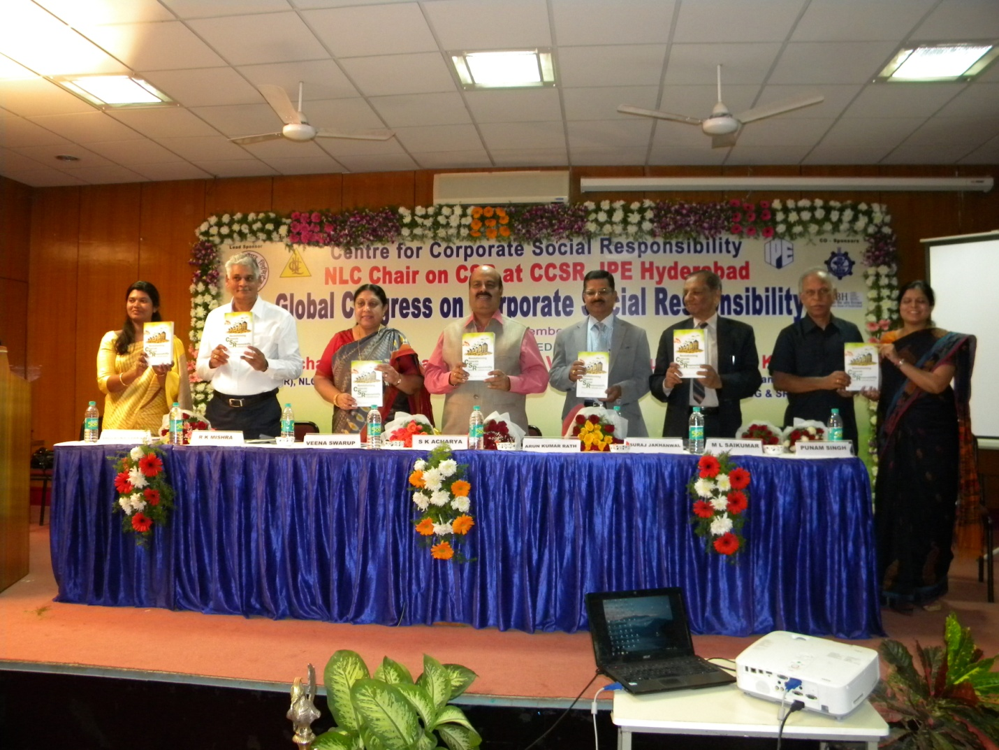
Ms. Veena Swarup, Former Director (HR), EIL released an edited book titled “Revolutionizing CSR: towards Sustainable Tomorrow”, as part of the congress. The other Dignitaries present at the Congress included Shri. S K Acharya, Director – HR Neyvelli Lignite Corporation, Neyvelli, Prof. A K Rath, (IAS), Chairman and Prof, Center for CG and SR at IMI, Delhi and Shri S Jakanwal (Retd. IAS), Task force member, GOI.
- Two Day International Conference on Corporate Social Responsibility, 6-7th of Dec, 2012.
The conference was organized with the objective of discussing CSR in the existing perspective and future outlook with focus on lighting up the challenges and the best practices in CSR. Professor RK Mishra, Director, IPE was the conference chair and the conference was convened by Dr. Shulagna Sarkar and Ms. Punam Singh. The conference was sponsored by NLC Ltd and the Co-sponsors were Andhra Bank and ALIMCO.
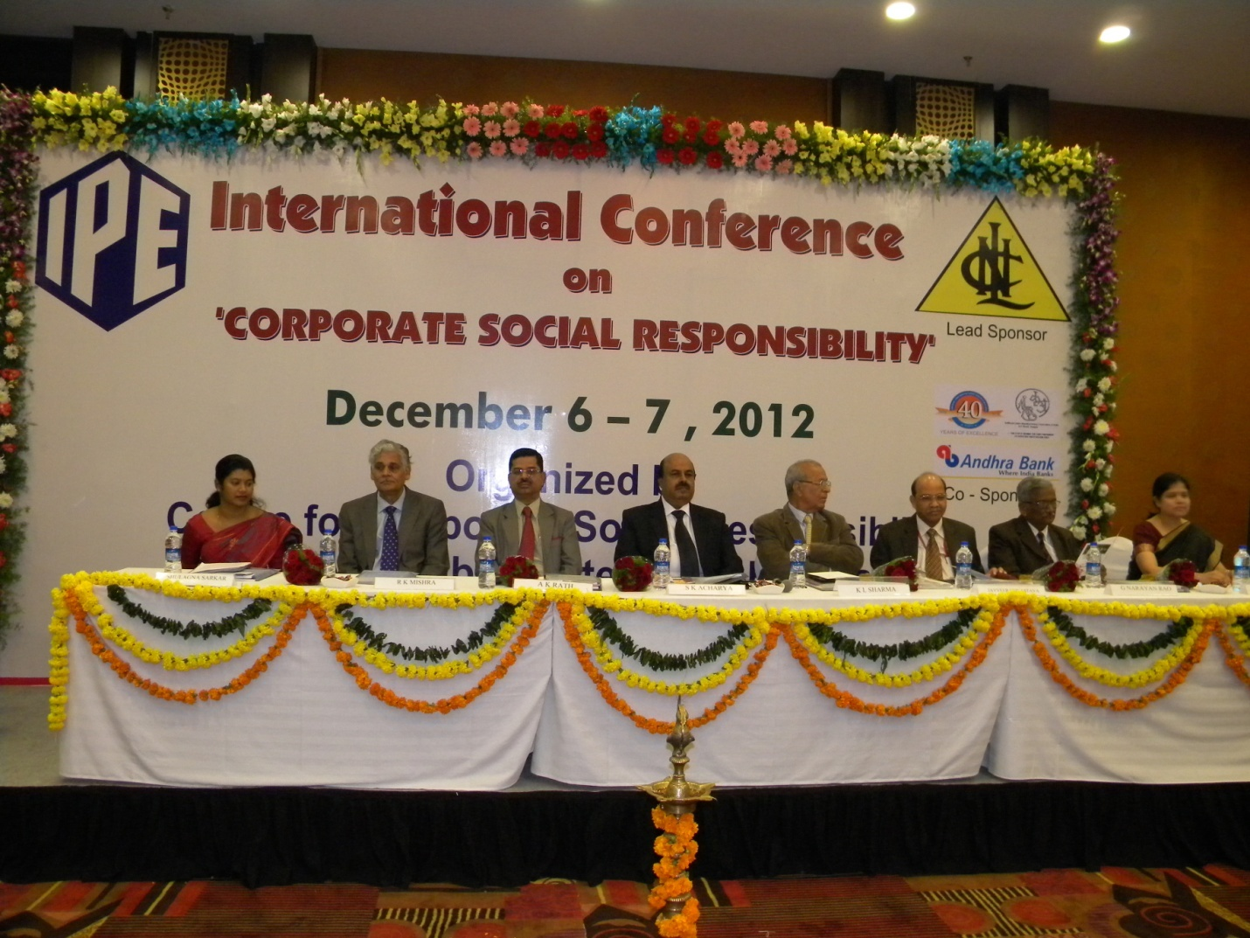

The inaugural function Guests included Shri. S K Acharya, CMD, NLC Ltd., Prof KL Sharma, Vice – Chancellor, Rajasthan University, Shri. Jayveer Srivastava, CMD, Hindustan Prefab Ltd, Prof. A K Rath, Chairman & Professor, Centre for CG& SR at IMI Delhi and Shri. G Narayan Rao, CMD, ALIMCO. The conference also severed as a platform for distinguished lectures by renowned speakers like Prof. AK Rath, Chairman and Director, Centre for CG& SR at IMI Delhi and Dr. Aditi Haldar, Director GRI Focal Point, India. The Guests for the Valedictory session included Mr. R Shankar Dr. Reddy’s Lab, Director (SHE) and Ms. Rajini Sinha, Regional Manager, Business Development, Akshyapatra.

- Two Day National Conference on ‘Best Practices in Corporate Social Responsibility’, 3rd -4th June, 2011

IPE ONGC Subir Raha on Corporate Governance and CCSR has organized a two day National Conference on ‘Best Practices in Corporate Social Responsibility’, 3rd -4th June, 2011. A book titled “Rethinking Corporate Social Responsibility” was also released at the inaugural function by Shri Bhaskar Chatterjee.

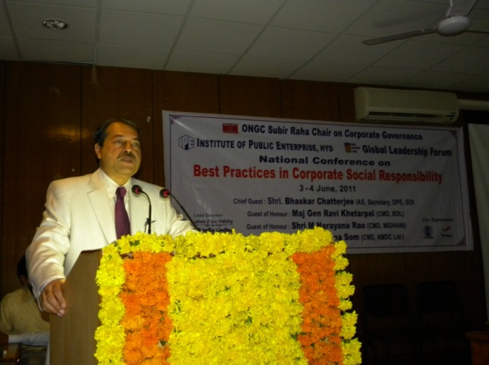 | 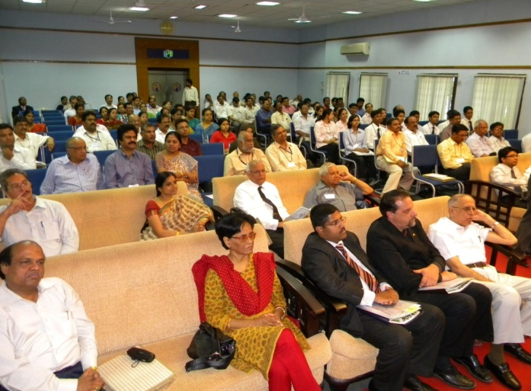
Shri Bhaskar Chatterjee, Former Secretary DPE addressing the participants of National Conference on Best Practices in Corporate Social Responsibility – 3rd – 4th June, 2011. | Participants at the National Conference on Best Practices in Corporate Social Responsibility – 3rd – 4th June, 2011.

- CCSR members attended two interactive workshops on ‘Training of Master Trainers on Corporate Social Responsibility’, organized on 5 and 18 July 2011 by DPE at New Delhi.

Members of centre for CSR have also attended two interactive workshops on ‘Training of Master Trainers on Corporate Social Responsibility’ 5th July, 2011.

Participants at the interactive workshops on ‘Training of Master Trainers on Corporate Social Responsibility’ 5th July, 2011.

Research
- Center for CSR has completed a “National level study on CSR” sponsored by ICSSR. The research is on “National level Study on CSR in India”

The national level study was conducted to meet the following objectives:
- To identify the CSR intervention areas for social inclusiveness in select backward regions across Northern, Eastern, Southern and Western zones of the country by conducting need assessment studies.
- To study the effectiveness of the existing CSR initiatives by measuring its impact in bringing social inclusiveness.
- To study the role of local government, role of corporation , role of local community , role of NGOs and other stakeholders in achieving social inclusiveness.

- IPE team has conducted numerous researches in the area of CSR. The team has exclusively worked in the area of CSR in Oil and Gas sector companies. The team is working on developing cases by studying the best practices in CSR of various public and private organizations.

CSR Initiatives of Center: IPE as part of its CSR initiatives has taken the responsibility of imparting quality training to enhance the quality of teaching. In this regard, the college conducts free FDPs for under- graduate faculty. Till date IPE has conducted 18 such FDPs.

NLC Chair on CSR
Institution of Chair on Corporate Social Responsibility at IPE by Neyveli Lignite
Corporation Limited (NLC) Ltd.

The NLC Chair on CSR was established at IPE through a MoU between the two organizations, signed on 22nd Feb, 2014 at IPE new campus at Shameerpet, Hyderabad. It is a progressive step by the two organizations towards its commitment to promote knowledge, experience and excellence in the area of CSR through research, training, workshop and work-association.
Objectives of the Chair:
- To identify and formulate the criteria and indicators of good CSR
- To integrate and standardize the existing body of knowledge, system, structure, models and mechanisms associated with different forms of practice of CSR.
- To derive mutually agreed upon CSR practices, beneficial to all stakeholders.
- To disseminate the information about the latest happenings in the field of CSR to the people engaged in policy making, policy analysis, policy research, the practitioners and other stakeholders.

